24.35: a) 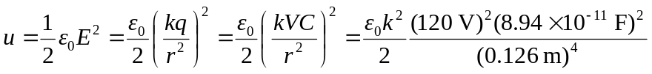
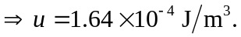
b) The same calculation for 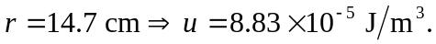
c) No, the electric energy density is NOT constant within the spheres.

